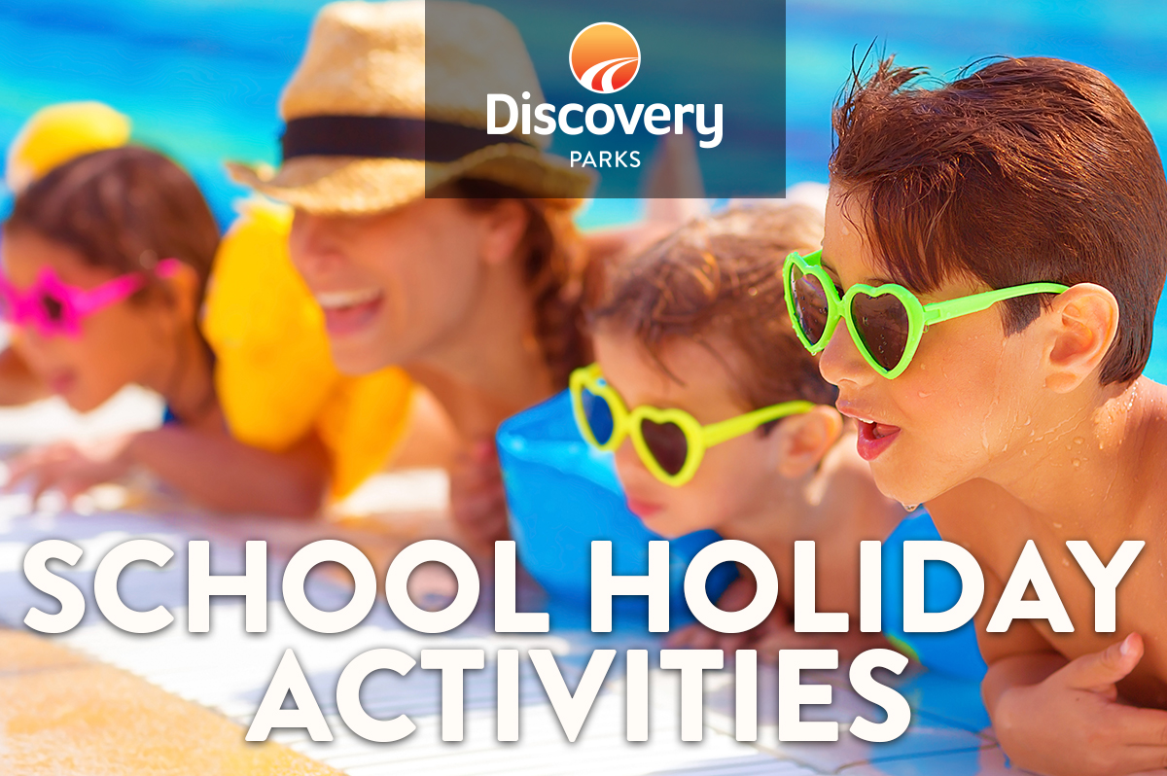
2019 WINTER SCHOOL HOLIDAYS
AT DISCOVERY PARKS – Lake Bonney
Lots and lots of great holiday fun for all the family. From Bonfires and Monster Marshmallows to movie nights and AFL matches on the Big Screen, there’s activities planned throughout the school holidays.

DATE | TIME | ACTIVITY | VENUE | COST
5th July  6th July  7th July  8th July  9th July  10th July  11th July  12th July | 6.30pm  7.30pm  6.30pm  All day  All day  All day  All day  6pm | Movie night  AFL – “Showdown” (Adelaide Crows v Port Power)  Bonfire with Monster Marshmallows  “Where’s Harry?”  Treasure Hunt  Colouring competition  Park Quiz  Movie night | Lake shed  Lake shed  Lake shed  Reception  Reception  Reception  Reception  Lake shed | free  free  free  free  free  free  free  free
13th July | 6pm | Bonfire with Beef Ragout/mash/damper, Sausage Sizzle and Monster Marshmallows,  AFL – GC Suns v Adelaide Crows | Lake Shed | $5/ $2/ 2 for $1
14th July | 5.30pm | AFL – Port Power v Brisbane Lions | Lake Shed | Free
15th July | All Day | Puzzle Day | Reception | Free
16th July | All day | “Where’s Harry?” | Reception | free
17th July | All day | Treasure Hunt | Reception | free
18th July | All day | Colouring competition | Reception | free
19th July | 6pm | Bonfire with Monster Marshmallows  AFL – Adelaide Crows v Essendon | Lake Shed | free
20th July | 6.30pm | Movie Night | Lake shed | free
21st July | 7:30am | Pancake Breakfast | Lake shed | $2

